

Aim for the Highest

Camden Haven High School
Targeted Sports Program – (TSP)

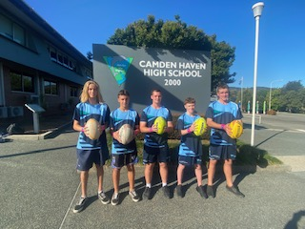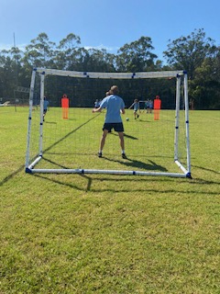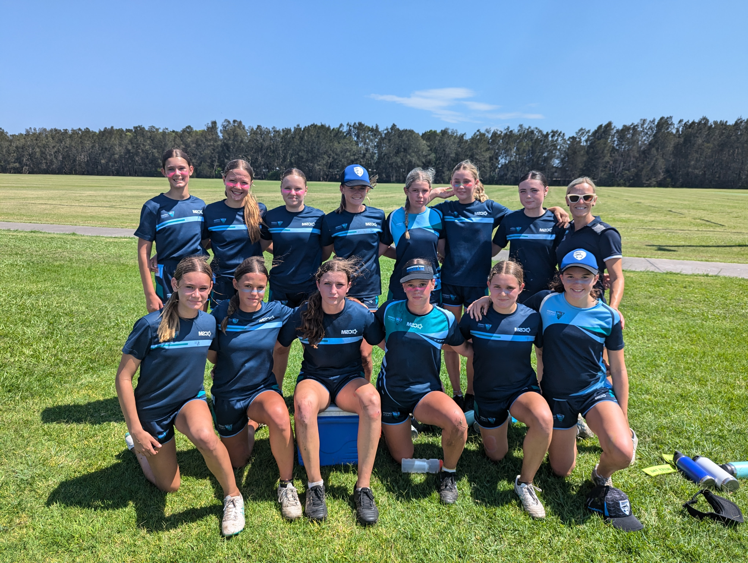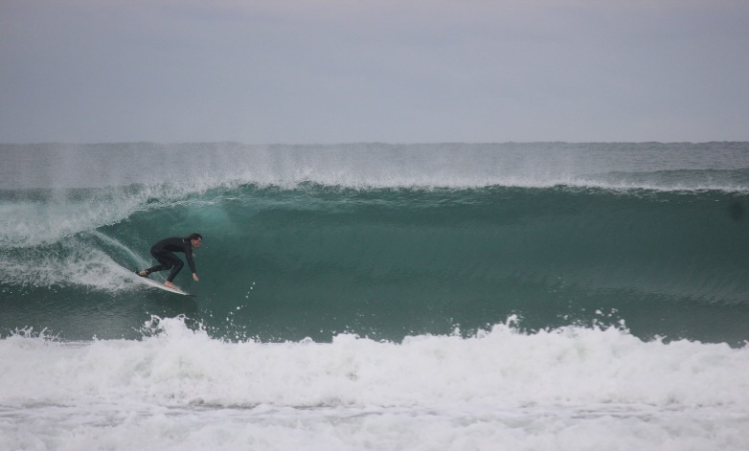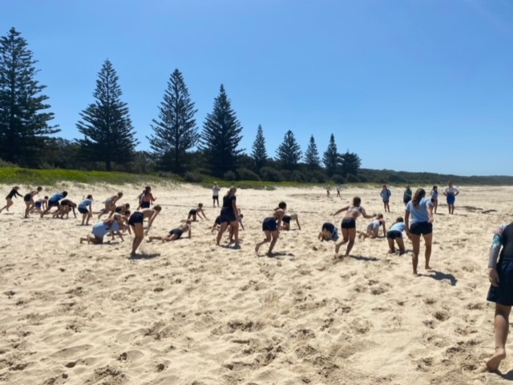

What is the Targeted Sports Program (TSP)?
The TSP is a selective sports program with five strands including Basketball, Soccer / Futsal, Rugby League, Girls Footy Sports & Surfing for selected students in Years 7-10.
All TSP strands engage in weekly skill development, conditioning, gameplay, coaching, teamwork & goal setting they also play interschool games on the North Coast and Hunter area.
The TSP students experience numerous extracurricular opportunities. These include utilizing community venues, Port Macquarie Recreation Games, training days, camps, NRL / A League / NBL excursions and surfing camps.
TSP is for 1 x 60minute timetabled lesson each week. Students are withdrawn from one lesson per week in 5-week blocks (same subject/lesson for those 5 weeks). Students can be supplied with their schoolwork to complete and submit at the end of the fifth week.
TSP students will be expected to complete a minimum of one gym sessions per week during lunchtimes. They will be provided with an individualised strength & conditioning program by CHHS strength & conditioning coach.
The program focuses on the school’s three core values - Respect, Responsibility, and Doing Your Best. Sport is the tool utilized to encourage students to become young men and women, however, students need to meet behavioural, attendance and training requirements to keep their position in the program.
Students are assessed on their behaviour, attendance, academic progress, effort, and application each 2-week cycle. TSP staff mentor students and work with them to improve their educational outcomes and achieve personal goals.
If students aren’t meeting TSP standards and / or are placed on a Deputy Principal level monitoring card, they are excluded from all TSP activities (lessons and extra-curricular) and wearing of the uniform until they satisfactorily complete their student monitoring. Continual poor behaviour and / or unexplained absences may lead to permanent removal from the TSP.
The program fee is $150. This includes training apparel (tee, shorts & jacket) & assists in subsidizing local travel. Additional apparel can be purchased on the order form.
Once students have paid the course fee, they receive their apparel. The apparel included in the program includes a training t-shirt, shorts, jacket, and backpack to wear at school, on training days, game days, and excursions.


What are the aims of the TSP?
To improve:
- Engagement with the school and the wider community
- Motivation levels
- Behaviour
- Attendance (>90% absences explained- 2-week analysis)
- Attitude
- Skill level

- Levels of achievement
- Knowledge and understanding
- Social skills
To provide:
- Expert coaching, opportunity and experiences
- Enjoyable and engaging learning environment
What will the students experience?
- Skill development
- Conditioning
- Modified games
- Free Fitness Centre Access for strength & conditioning training
- Game play
- Pursuing and achieving excellence
- coaching Rugby League / Futsal / Soccer / Touch / League Tag / Basketball/Surfing
- Recreational activities (fitness and teamwork utilising community venues)
- NRL / A League / NBL / extracurricular activities including overnight camps.
What are the expectations of the students involved?
- Complete and submit the TSP application by the due date with all sections completed, including the attendance evaluation & commitment, the student questionnaire and permission forms.
- Complete at least one gym sessions per week during lunchtime and/or sport (program developed by our strength & conditioning coach)
- Resolve any issues with teachers by completing detentions / consequences.
- Have at least 90% of absences explained
- Wear full school uniform. TSP uniform only on training days.
- Behave appropriately in all classes.
- Actively participate in all program activities and sports relating to their TSP strand
- Demonstrate a positive and enthusiastic attitude.
- Bring the correct equipment and uniform for training days.
- Be on time to all program activities.
- Complete any missed class work when requested by your teacher.
- Assessment tasks take priority over training sessions.

Can students be excluded from the TSP?
YES!!
- Either for a specified period of time or permanently.
- It is a privilege to be selected for this program.
- It is the student’s responsibility to meet all expectations- uniform, behaviour, attendance & gym sessions.
- An exclusion period will take place if a student is placed on a Deputy Principal level monitoring card or there is continual or ongoing issues and/or truancy of classes.
- The student will be reinstated into the program upon successful completion of all monitoring cards and the resolving with of any issues with teachers and/or students.
- Failure to meet the outlined expectations will result in exclusion from the program until the student can demonstrate satisfactory behaviour.
- Any suspension from the program is at the discretion of the TSP Coordinator.
- More than two exclusions may result in permanent removal from the program.


Who are the TSP Coordinators?
- Mr S Vonbun (TSP Leader and Rugby League)
- Mr T Rodgers (TSP Rugby League)
- Mr J Hinchcliffe (Basketball)
- Mr R Rowe (Soccer / Futsal- Boys & Girls)
- Mr B Wilkinson/Ms Butler (Footy Sports- League Tag / Touch- Girls only)
- Mr D Schouten/Mr Bromhead (Surfing)

What are the TSP Coordinator responsibilities?
TSP Coordinators trial, select, train, and complete all planning, communication, and organisation for their TSP groups. They work closely with parents as required. They mentor and monitor their students’ progress across the whole school. They are available to help improve the young person as a whole and assist them in reaching their potential in all areas of their schooling and life.
How do students Trial for the TSP?
- Students must submit their name to trial for one TSP strand.

- They require parent approval.
- Students will participate in a variety of training sessions during Term One, on and off the school -site, at lunchtimes and during sport to test students’ physical and mental capabilities along with their skill and abilities, fitness, attitude, commitment and dedication. (If students are at school, they are responsible for being at the Trial sessions).
- Students’ behaviour, attendance, and attitude in school must meet CHHS expectations. Monitoring of student attendance and behaviour records is ongoing.
- The selection period will finish with an interview with the TSP Coordinators and a thorough assessment of the student’s progress throughout the TSP trial period.
- The final TSP squads will be selected and announced on assembly.
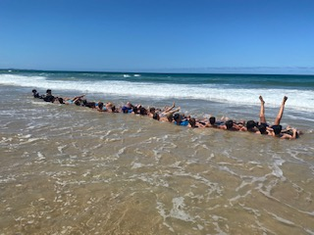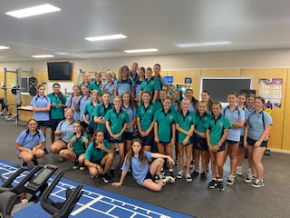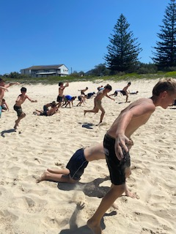
What else is involved in the TSP?
- Term 1 Week 10 there is a reward recreational games excursion Periods 2-5
- At various times throughout the year TSP groups will play inter-school games against other local High Schools. There will be a maximum of three inter-school games per strand.
- Each TSP strand will have a professional experience excursion during Term 3 or Term 4 where they may attend an NRL, A-League, NBL, match, Surfing with a game against another school.
What happens when students miss a lesson due to TSP training?

- The teacher can provide the student with 5 lessons of classwork to be completed and submitted at the end of the 5-week block. If a student is provided with work or instructions of what work must be completed the student must complete the work as negotiated with their teacher.
- Assessment Tasks take priority over training sessions. For all TSP-related excursions or playing a game standard school process will apply. Students must negotiate an alternate time to complete the task. The TSP Coordinator can assist with supervision.

TSP Sample Program Outline (subject to change)

Week | Term 1 | Term 2 | Term 3 | Term 4
1 | - TSP promoted to students  - Nominate to trial assessment of skill, ability, fitness, game play, attitude, behaviour and attendance  - Beach games / fitness  - Pool games / fitness  - TSP squad announced & presented with uniforms  - Sport specific skills, plays and team structures begin | Practical  - Specific game-based skills and team structures (CHHS and / or community venues)  - Gym sessions  - Sport specific Game play  Game V School  Recovery Week  - Modified games in school competition | - Sport Specific game-based skills and team structures (CHHS and / or community venues)  Game V School | Practical  - Modified games  - Rec games  - Camp preparation  End-of-season camp  (TBA)
2
3
4
5
6 |  |  | NRL excursion (Newcastle)
7 |  |  | Recovery week
8 |  |  | Game V School
9
10 | Port Macquarie Recreational Games and BBQ |  | Modified games

Training Apparel - Students can purchase additional clothing
Additional Cost: $30 Shirt $30 Shorts $75 Jacket $40 Backpack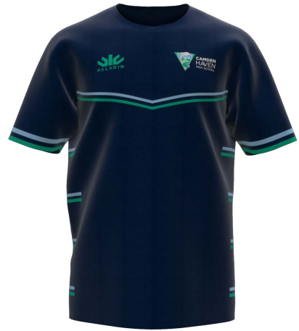 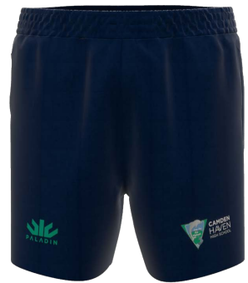 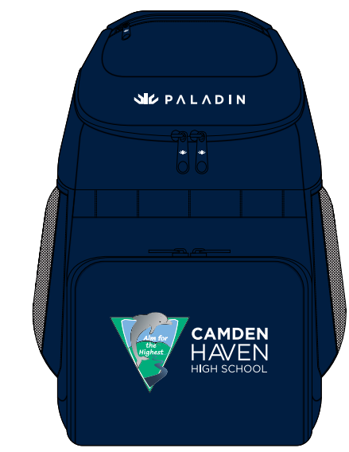

When is TSP on

- TSP is for 1 x 60minute timetabled lesson each week. Students are withdrawn from one lesson per week in 5-week blocks (same subject/lesson for those 5 weeks). Students can be supplied with their 5 lessons of schoolwork to complete and submit at the end of the fifth week whilst they participate in TSP. If the work is supplied and not completed the student is removed from TSP until it is submitted.

- Assessment Tasks take priority over training sessions. For all TSP-related excursions or interschool games standard school process will apply. Students must negotiate an alternate time to complete the task. The TSP Coordinator can assist with supervision.

- Term 4- TSP once per cycle

What else must I do if I’m in TSP?

- Free Fitness Centre Access for strength & conditioning training

- TSP students are expected to complete a minimum of one gym sessions per week during lunchtimes. They will be provided with an individualised strength & conditioning program by CHHS strength & conditioning coach. (This can be during sport time)

- Student Centered TSP teams meetings twice per term in weeks 1, 5 & 9 to assess student progress at school. TSP Student interviews will be conducted as required and if any intervention is needed due to poor behaviour, attendance etc this will be actioned starting at the Values Card level.

- Students are placed on an exclusion period for any DP level monitoring card (no TSP uniform until exclusion period is complete)

- More than 2 red cards can be permanent removal.

- Have at least 90% of absences explained or excluded until this standard is met.

- TSP uniform is only worn by students in TSP for 2025 at school, for training and extra-curricular activities.

