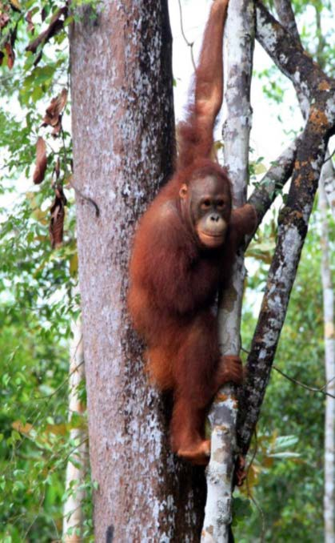
Camden Haven High School's
Borneo Excursion
April 2019

Where: Sumatra and Borneo
Proposed dates: 13th – 27 July 2019 (Last week of July holidays, first week of Term 3)
What:
This excursion allows students to be inspired and engaged in a potentially life-changing way. They will form relationships with young Indonesian people, helping to build a bridge between our two countries. They will learn to communicate in Indonesian with the local people. Beyond the language learning benefits of an excursion to Indonesia are the intercultural benefits. Interacting with local people, staying in local hotels, eating in local eateries, and being surrounded by all things Indonesian will have a profound impact on students’ understanding of the Indonesian culture and way of life. These rich cultural experiences are essential to intercultural understanding and can only be achieved by a visit to the country. They will also gain huge insights into the environmental issues which are threatening iconic animals like the orangutan.

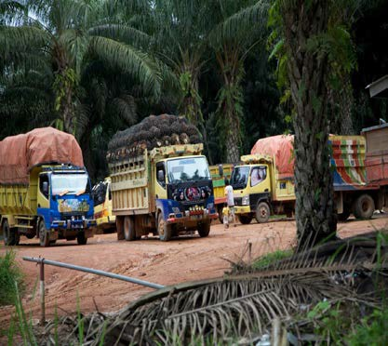

Students will have the opportunity to visit an orang-utan sanctuary, an orang-utan clinic and help make enrichment items for orang-utans. They visit a traditional Dayak (indigenous) village in Tembak, Central Kalimantan in which they learn about sustainability, palm oil, habitat loss and what they can do about it in their daily lives. They will be involved in community development programs and cultural activities with the local indigenous Dayak people.

Please see Youtube clip at https://bit.ly/2GbJjzZ for overview of excursion (minus sister school visit).

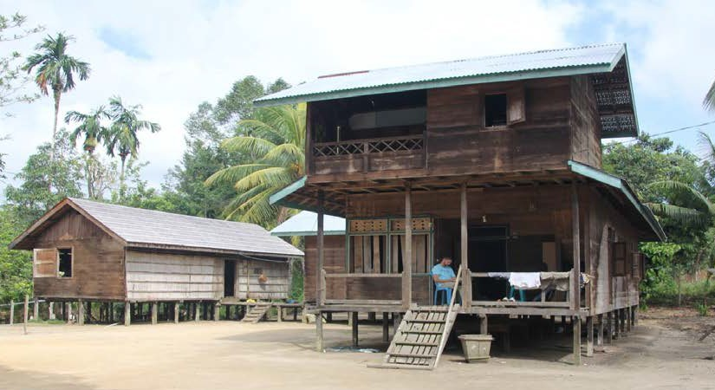
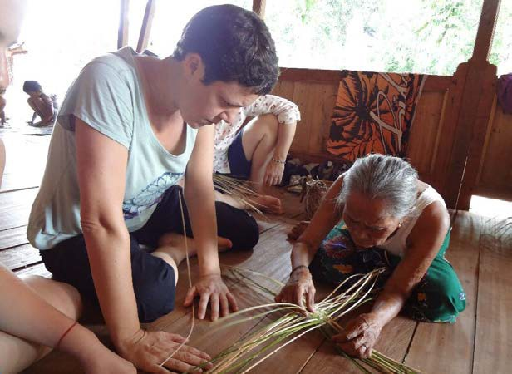
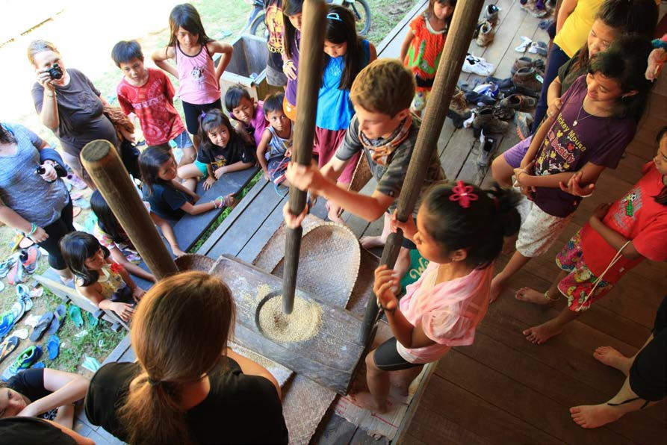
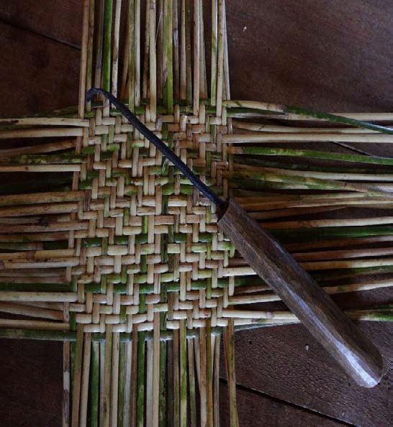

The second week we will visit our BRIDGE partner school in West Kalimantan, Borneo. Students will have an opportunity to meet young students, teachers and community elders, communicate in Indonesian, and learn first-hand about Melayu, Tionghao and Dayak culture. They will engage in community development projects while in Singkawang.

Costs
•The cost of this tour will be approximately $3000 per student depending on numbers. This will include a staff content ratio of 1:10.
Costs not included

•Vaccinations and medications
•Passport related fees
•Travel bags (suitcases are not advisable), mosquito nets, sleeping bags, travel pillows, self-inflating mats, hiking boots and other travel related items (a detailed packing list will be provided once participants are confirmed)
•Some meals

This price includes:
•Economy class airfare
•All taxes, transfers and tours
•All sightseeing and entry fees
•Accommodation in both hotels and communities
•Full Comprehensive Travel Insurance
•Most meals
•Trip of a lifetime

…………………………………………………………………………………………………………………………………….
Please return to either Mr Rourke (65568126) or Ms Wilkinson at Camden Haven High School (65568174)

Expression of Interest for Sumatra / Borneo Excursion
Name ………………………………………………………………………………………………………………………………………………………………………………….. Address………………………………………………………………………………………………………………………………………………………………………………… Home telephone number …………………………………………………………Parent’s mobile number ………………………………………………….. Student’s mobile number …………………………………………………………………. Year ……………………………………………………………………… Email Address ……………………………………………………………………………………………………………………………………………………………………… School ……..…………………………………………………Night suitable to attend meeting ……………………………………………………………….
Parent’s Signature ……………………………………………………………………………………………………………………………………………………………….

